

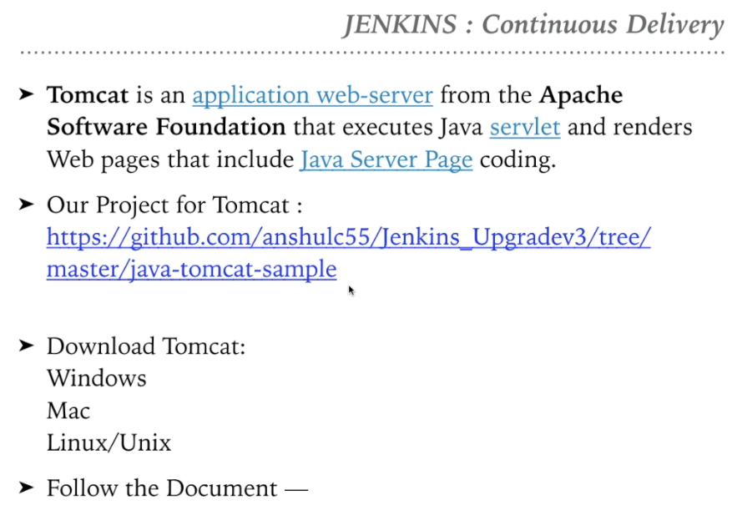

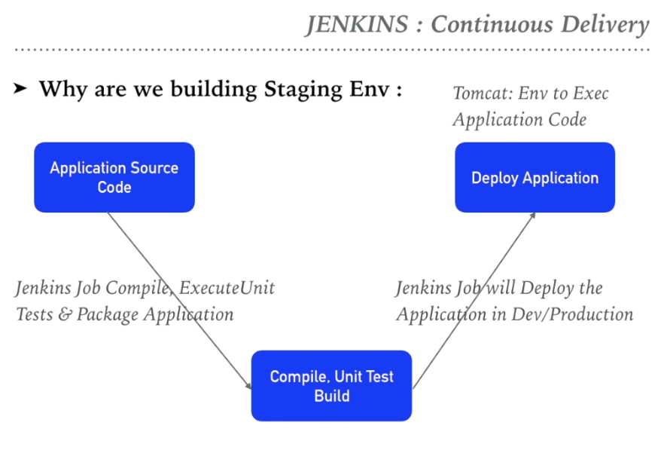

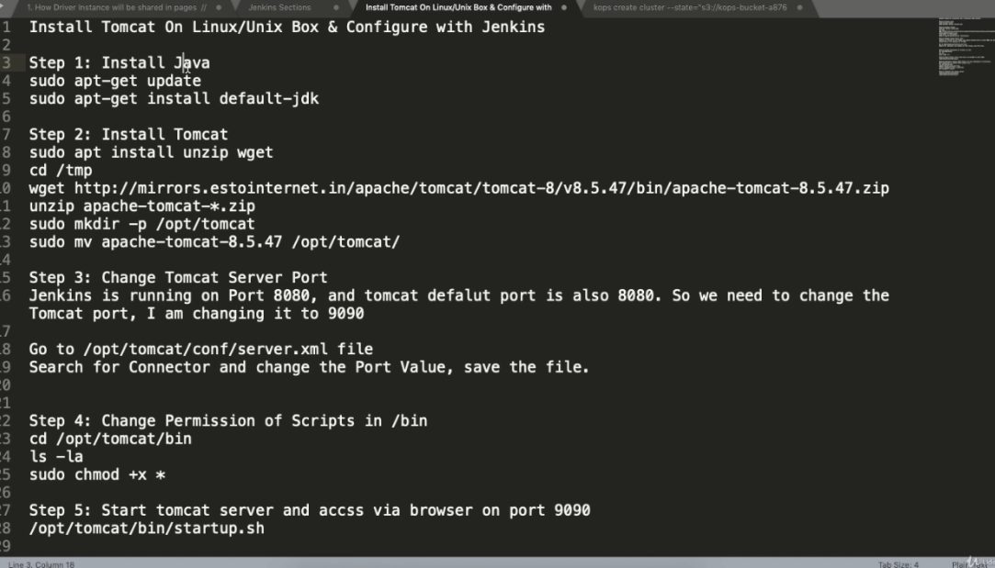

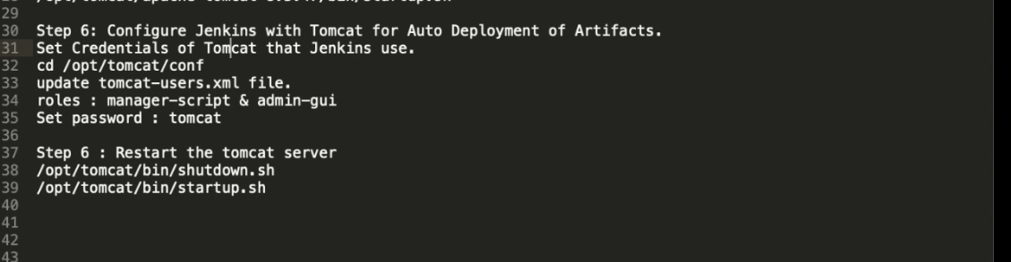



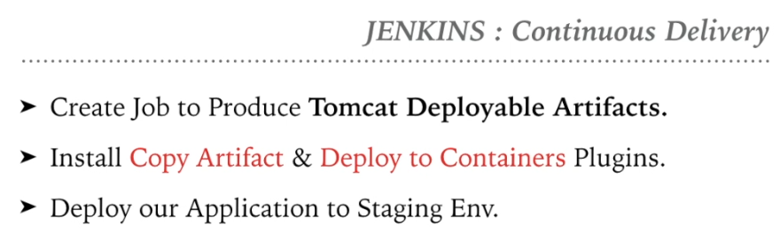

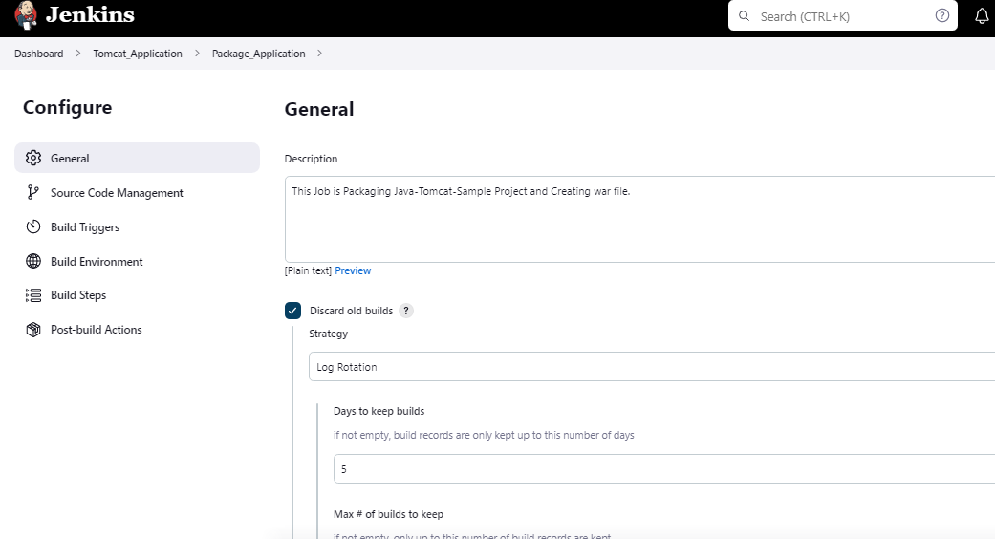

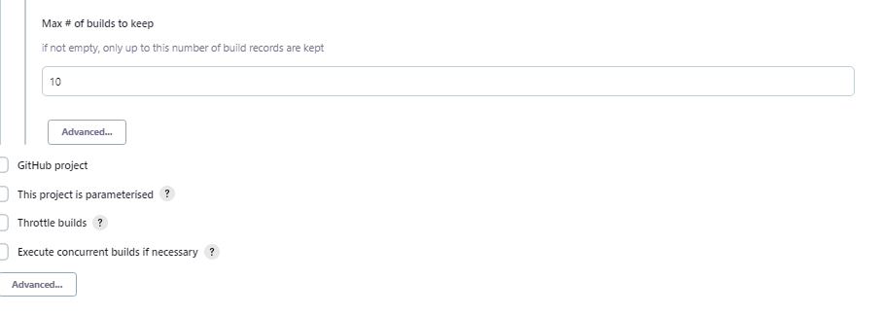

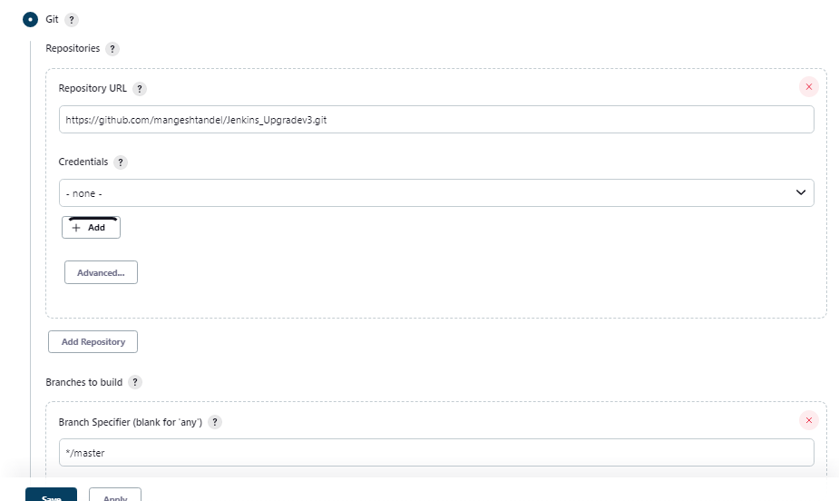

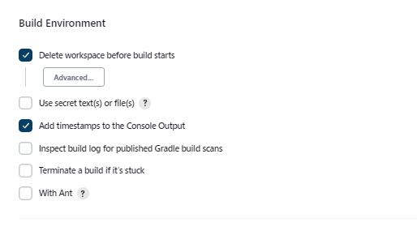

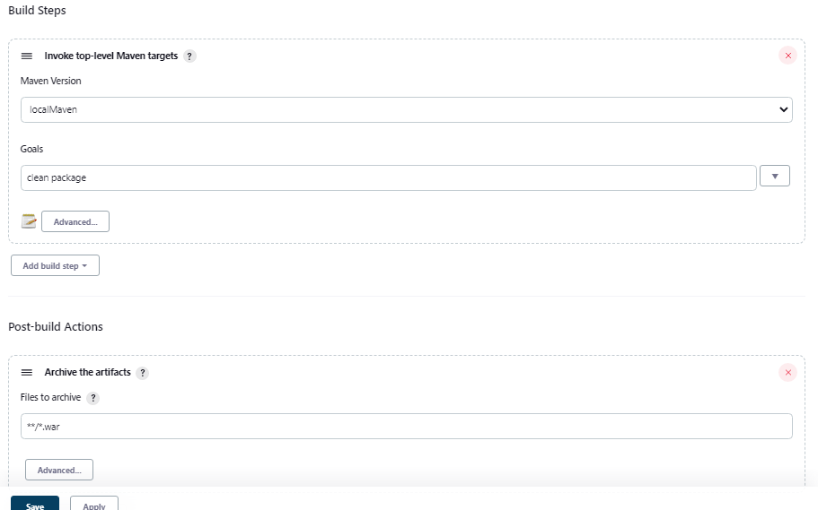

After saving try running the tomcat Jenkins job sample.

Go to Jenkins > manage > plugins >

Download 2 plugins

Copy architect

Deploy to container.

After plugin installation we need to create new job :

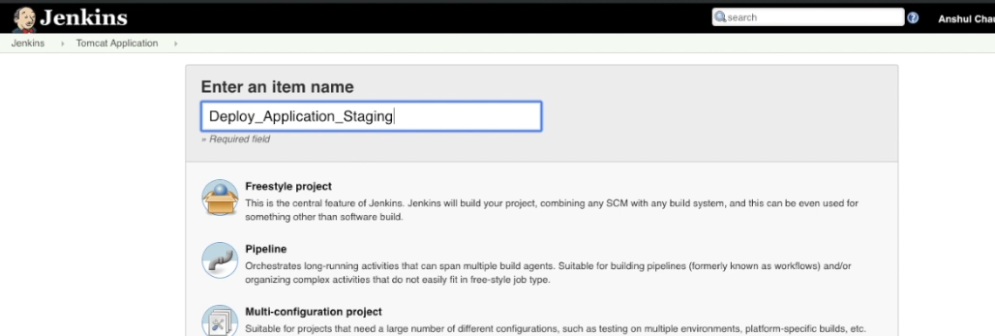

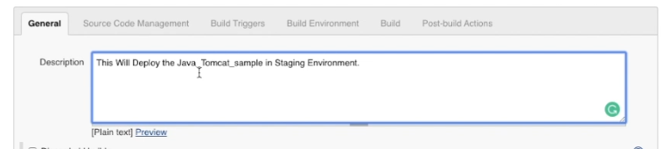

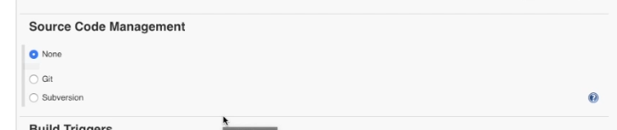

Build Triggers nothing to add.

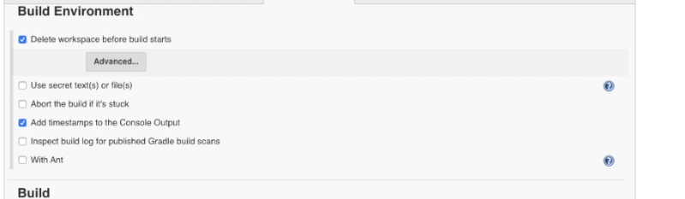

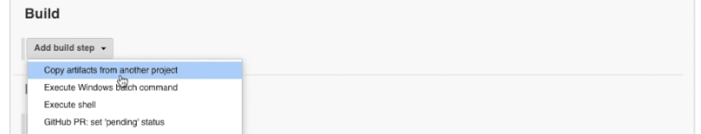

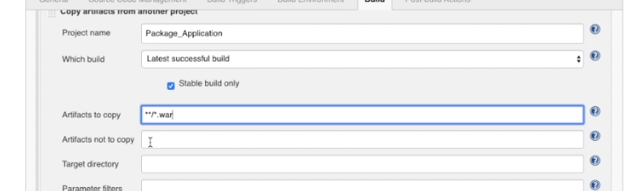

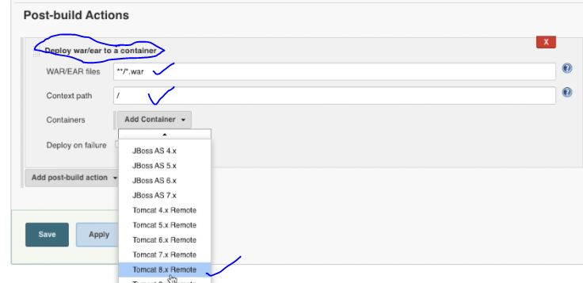

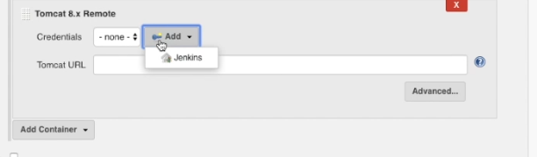

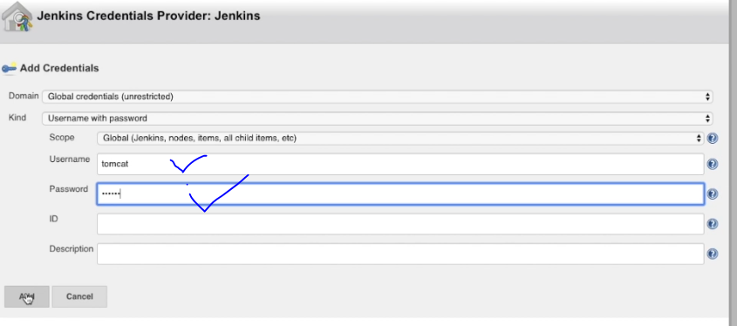

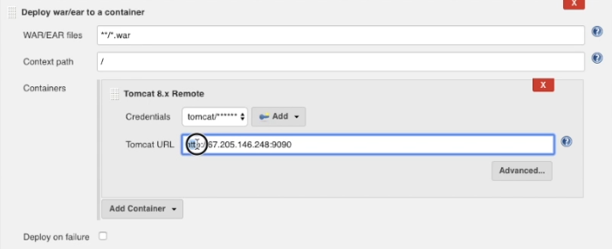

Save the job and test manual running

You will get some error in job below, do the setting as given in below screenshot :

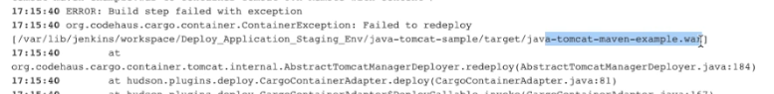



Rectify using changing the below in $HOME_TOMCAT/conf/, changing to manger-gui

root@linux-jenkins:/opt/tomcat/apache-tomcat-8.5.83/conf# pwd

/opt/tomcat/apache-tomcat-8.5.83/conf

tomcat-users.xml file

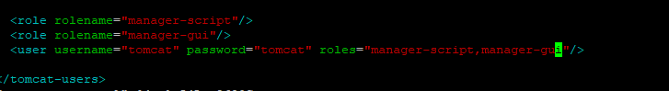

Shutdown and restart tomcat and check if its working.

IF you get below error :

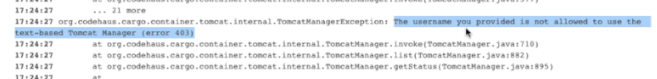

Goto below :

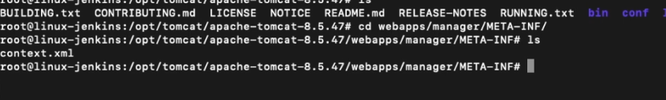

And comment below :

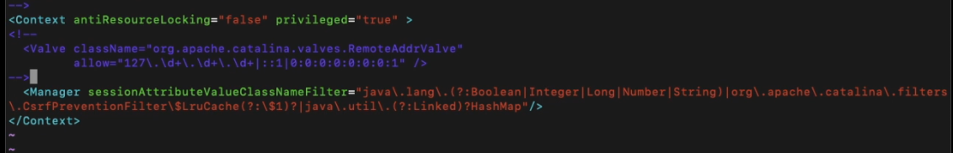

And try running the job again. After restarting the tomcat again. If it successfully run, check in browser :

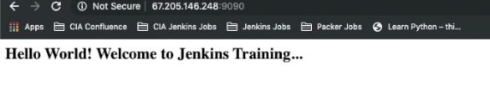

NOW LETS MAKE THIS JOB DEPENDENT ON EACH OTHER>

Go to first job and run following :

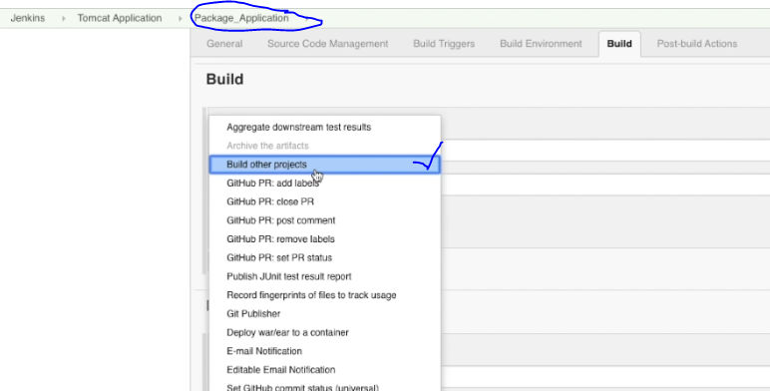

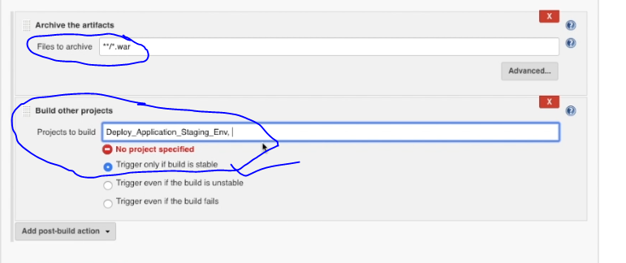

Also set Poll SCM

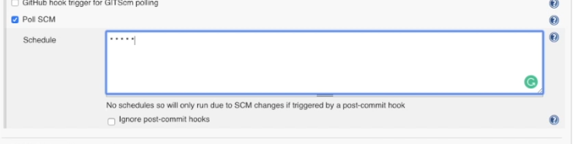

Now as soon you do changes in jsp file

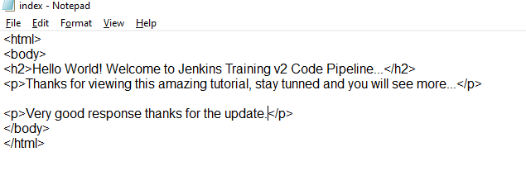

And commit the changes, the job will be reflecting in website for new artificat war file created in jobs.

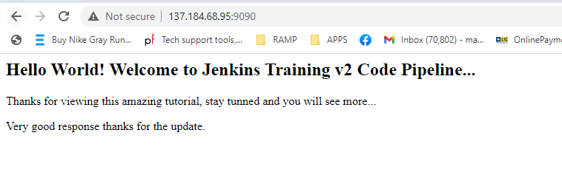

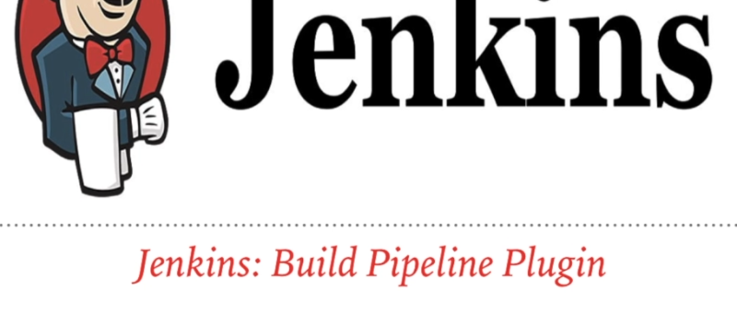

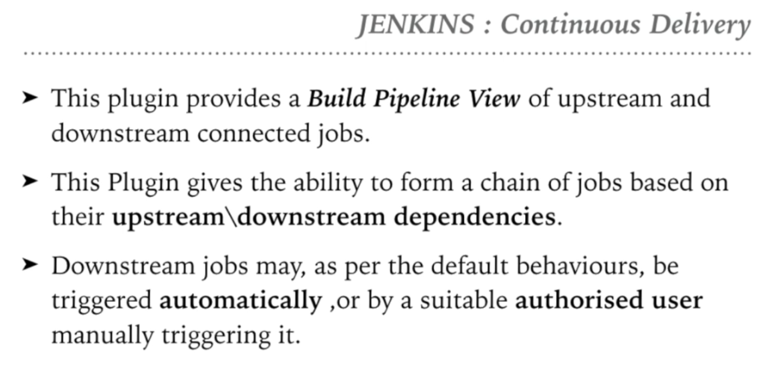

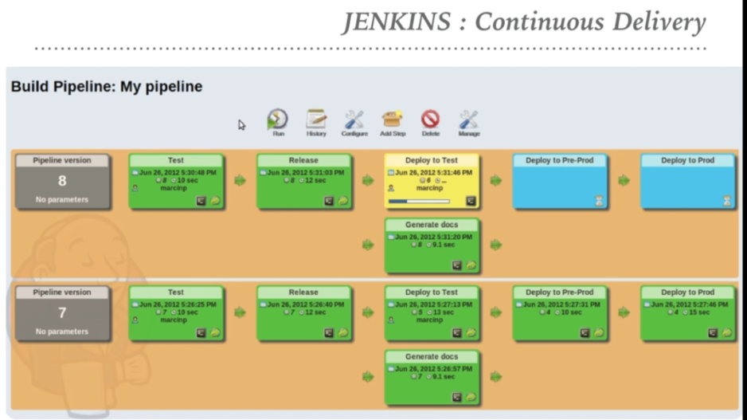

Install th below plugin in Jenkins > manager >

Build pipeline.

And make new view by + button.

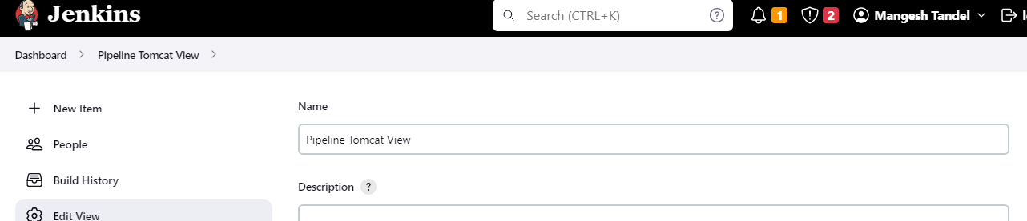

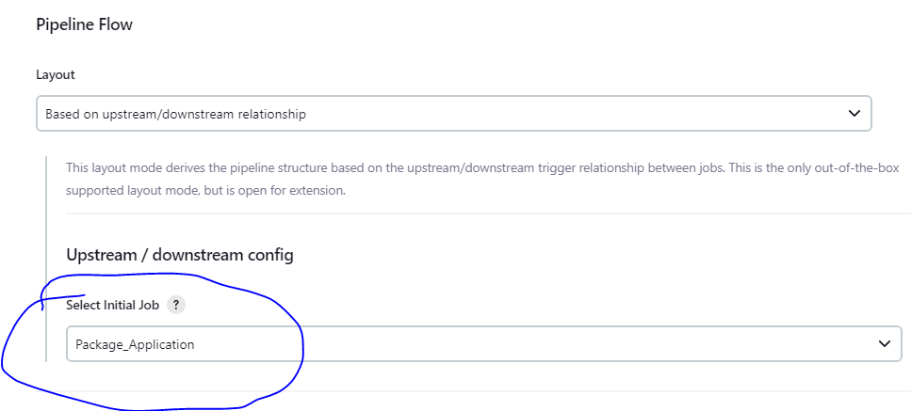

And save the project.

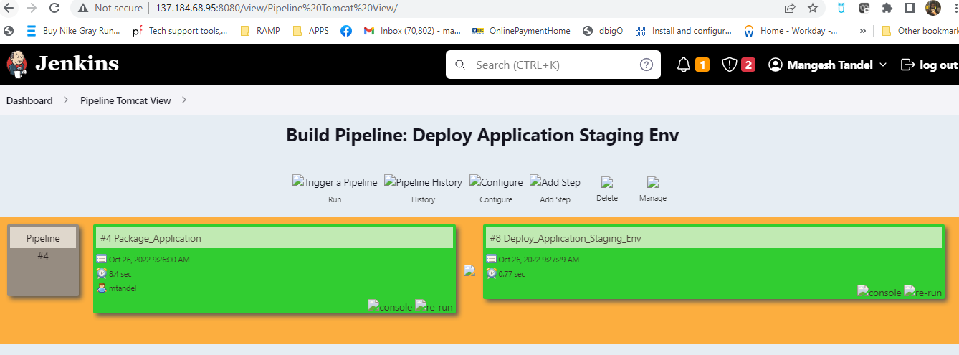



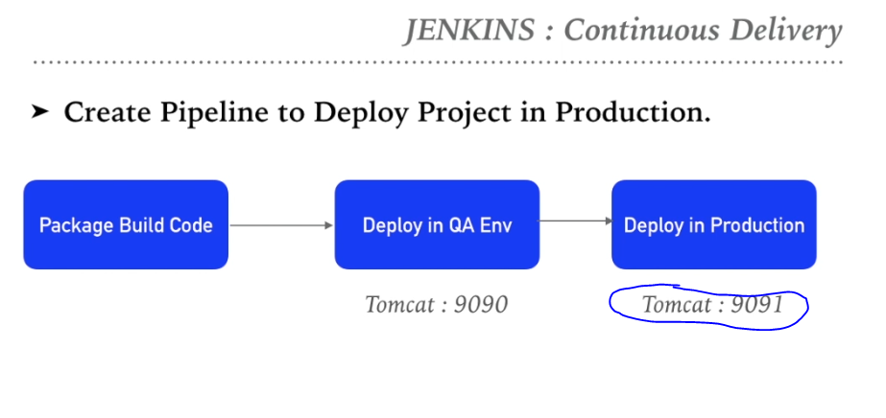

Go to existing tomcat server and shutdown tomcat :

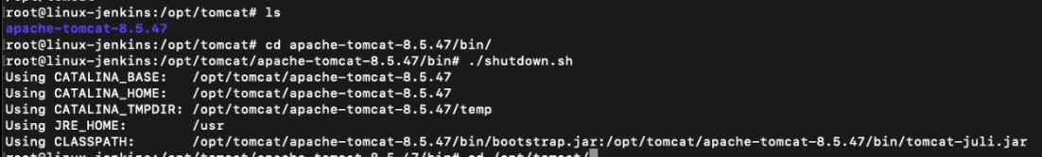

Now create similar directory as tomcat as below :

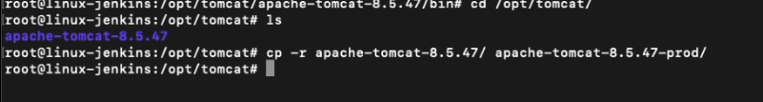

After copying the file go to server.xml file and change the port of prod to 9091

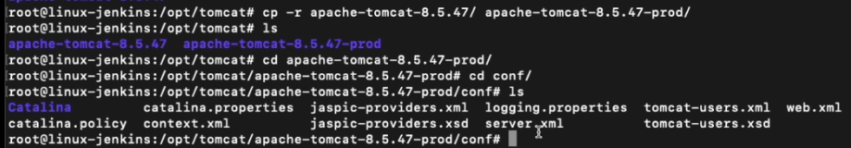

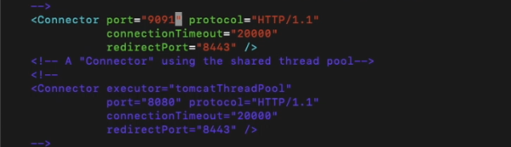

Now save and start the tomcat on staging server by start.sh script in apache-tomcat/bin/start.sh script.

Check log here for starting :

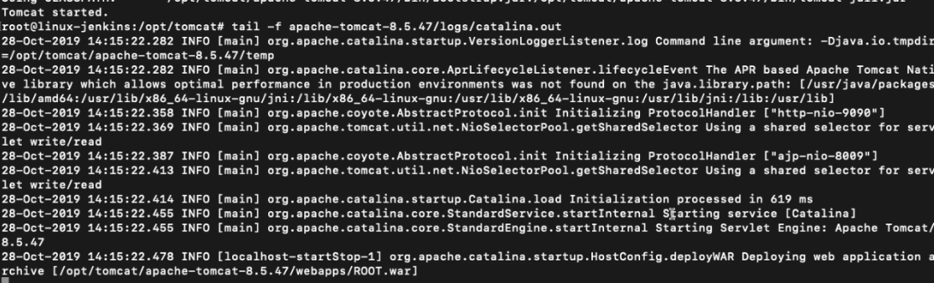

NOW start on prod.

